Acknowledgement
This report was an independent study conducted at a major US corporation. We want to express our appreciation for permission to publish these results.

ALTERNATIVE MOUSE STUDY

For ten weeks an Ergonomics Team at a major semi-conductor manufacturer, conducted a study to determine what the best and worst pointing devices are for the office environment. The intent of this information was threefold: to help identify root causes of injuries, to aid in making office ergonomic recommendations, and to initiate a mouse “library” program where employees can test alternative pointing devices on a trial basis.
At the beginning of each week, the study’s ten participants received a new pointing device to be used for regular computing use. At the conclusion of each week, surveys were completed and results were compiled. To make sure statistics were accurate, every person tested every mouse in a different order.
What follows are results of the Alternative Mouse Study. The results of this report compare and contrasts the ten mice.

Mice tested

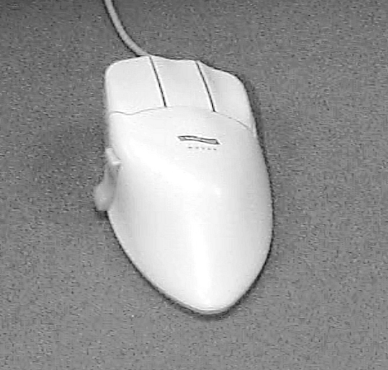
Contour Mouse (Medium Sized Only)

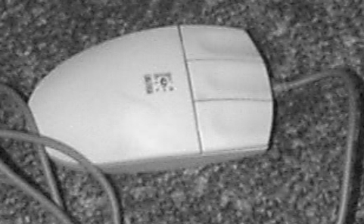
Logitech Flat Mouse

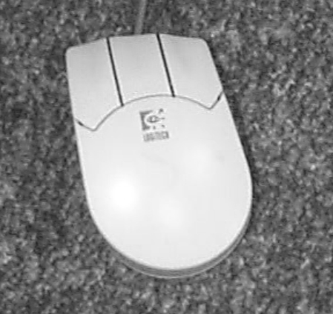
Logitech Curved Tilted Mouse

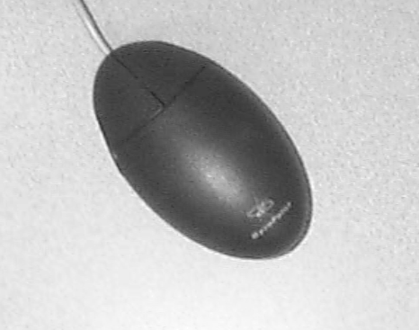
Gyropoint Mouse

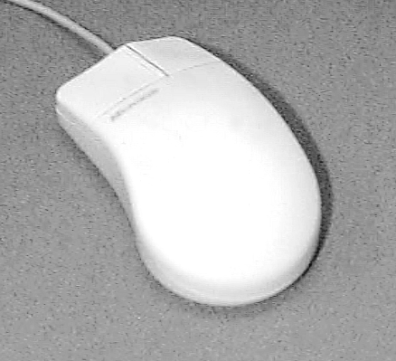
Microsoft Mouse

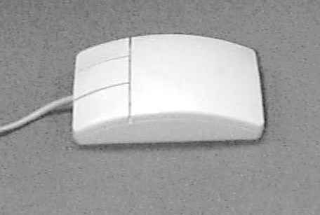
Hewlett-Packard 3-Button Mouse

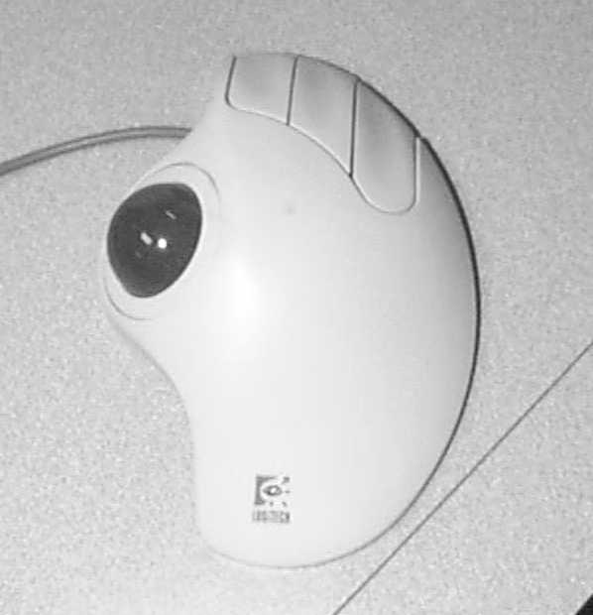
Logitech Marble Trackman

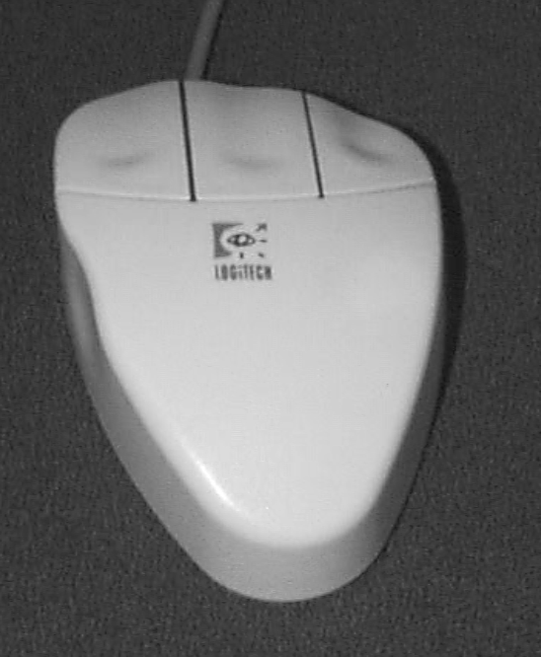
Logitech Pointed Tilted Mouse

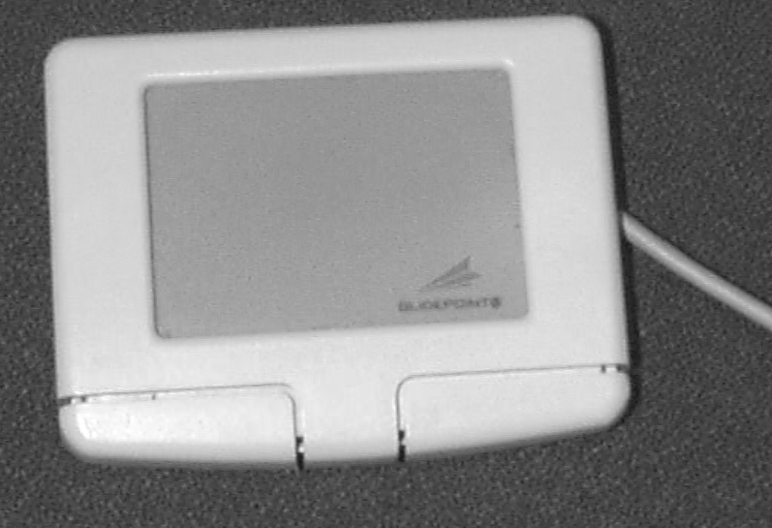
Glidepoint

Part I - Comparison

Percentage of participants that say mouse is a viable option

Contour Mouse | 100%
Logitech Flat Mouse | 100%
Logitech Pointed Tilted Mouse | 100%
Microsoft Mouse | 100%
Gyropoint Mouse | 78%
Logitech Curved Tilted Mouse | 75%
Trackman Thumb Trackball | 44%
Glidepoint | 0%
Hewlett-Packard 3-button Mouse | 0%
Microspeed Large Trackball | 0%

Question 1: Overall, how would you rate the pointing device for office tasks?
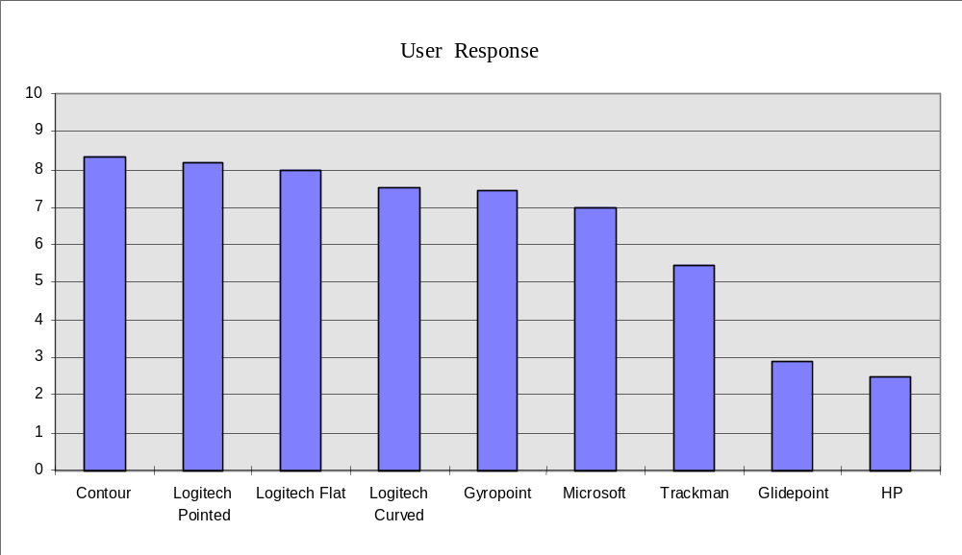

Question 2: How would you rate the comfort of the buttons on the pointing device?
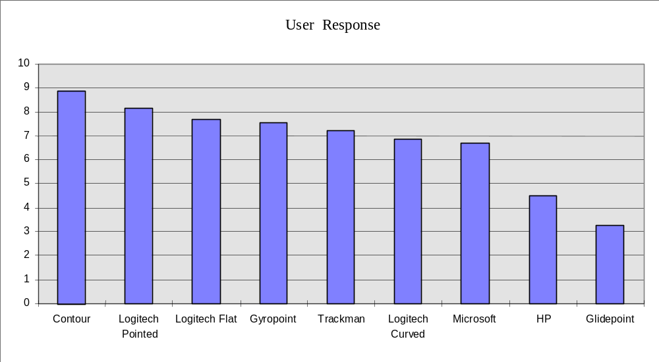

Question 3: When using the pointing device, do you find that your fingers feel tense(1) or relaxed(10)?
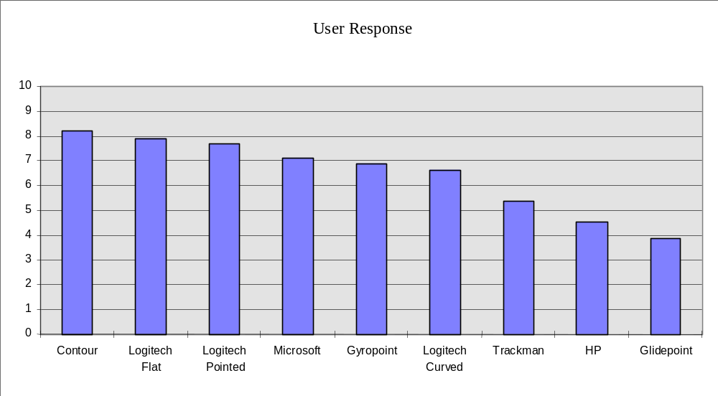

Questions 4: How would you rate the drag and click capability of the mouse?
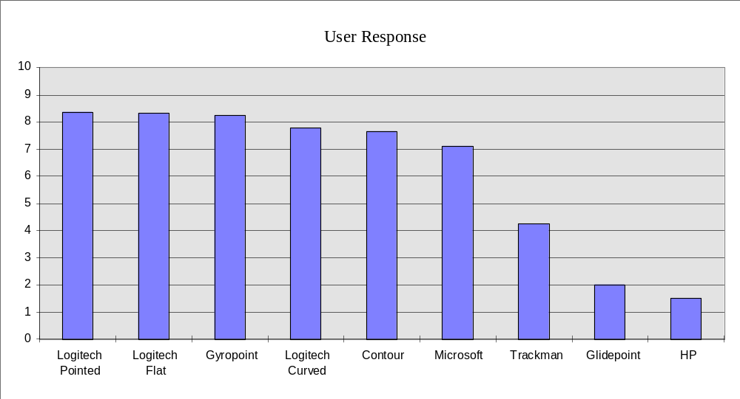

Question 5: How would you describe the accuracy of the cursor movement?
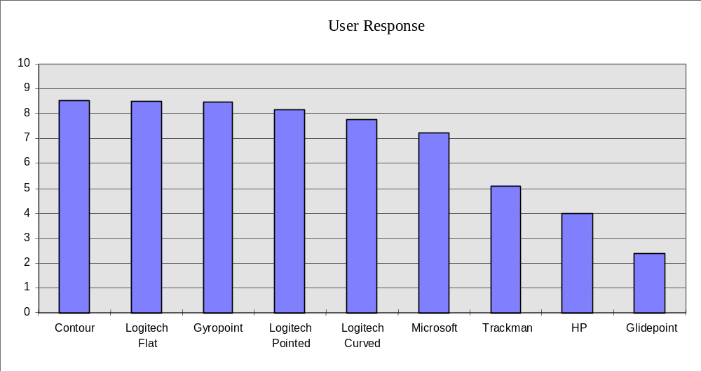

Question 5: Overall, how would you rate the pointing device for office tasks?
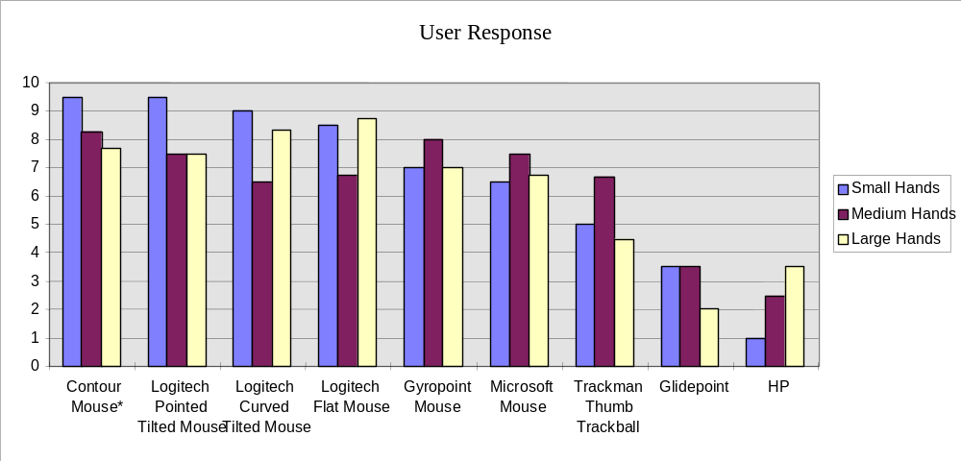
* The Contour Mouse was tested with Medium Sized version only.

Contour Mouse

Overall, the Contour mouse received the highest scores. Most comments were very enthusiastic. The only negative comments were: “takes getting used to”, “too large”, “can’t use with wristrest”. The Contour is available in ex-small, small, medium, large and ex-large sizes. We used the medium size in our study for all participants. It is also available for left hands.
The Contour mouse was most popular among people with small and medium hands. It was the very best mouse in terms of comfort and accuracy, but placed lower in the drag/click category. Contour is one of the larger mice in our study, and has a thumbrest built into the side.

Summary

It is clear that in almost every category, we see a significant difference between “good mice” and “bad mice”. By looking at the data for overall mouse performance (page 2) we see that 6 mice score highly in all categories. The graph shows a large drop between the first six mice and the last three mice.

Based on this study, these mice are recommended:

- Contour Mouse*
- Logitech Pointed Tilted Mouse
- Logitech Flat Mouse
- Logitech Curved Tilted Mouse
- Gyropoint Mouse
- Microsoft Mouse

It is important to note that no matter how highly a mouse is recommended, it cannot solve the problems of office ergonomics. It is up to each individual to make sure he or she is working safely through application of ergonomic principles and Best Known Methods. This includes a properly adjusted workstation, chair and monitor, a comfortable keyboard, and a comfortable mouse. Each employee should have an ergonomic evaluation on their office area, take the Office Ergonomics class, and should take frequent stretching breaks.

Manufacturer Name Visual Description Model Number
Contour Contour Mouse, Medium PC-M-R
Logitech Triangular Tilted M-CQ38
Logitech Curved Non-tilted M-S35
Logitech Curved Tilted CR32
Gyropoint Gyropoint Mouse 9200-B
Microsoft 2-button Compatible Mouse 2.0A 58269

